URGENT Field Safety Notice

M5071A (adult) and M5072A (infant/child) pads for use with HS1/OnSite/Home AEDs may experience gel separation and reduction of gel surface area

21-FEB-2022

This document contains important information for the continued safe and proper use of your equipment

Please review the following information with all members of your staff who need to be aware of the contents of this communication. It is important to understand the implications of this communication.

Please retain a copy with the equipment Instruction for Use.

Dear Customer,

A problem has been identified in the Philips M5071A (adult) and M5072A (infant/child) AED pads that could pose a risk for patients or users. This URGENT Field Safety Notice is intended to inform you about:

- What the problem is and under what circumstances it can occur

HS1/OnSite/Home AED pads (PN: M5071A, M5072A) have been observed to experience gel separation from the foam/tin backing when peeled from the yellow plastic liner. The gel may fold onto itself resulting in reduced surface area of gel on the pad, or it may separate almost completely leaving only a small amount of gel on the pad. Any pad currently installed in or stored with an HS1/OnSite/Home AED could experience this problem, and it is not possible to know prior to patient use if your pad is affected because the pads are protected by a foil seal. Philips has received 115 complaints about this issue since 2010 (of which 84 complaints were received in 2021) for a total of approximately 5 million shipments of M5071A and M5072A pads. Users should continue to use the HS1/OnSite/Home AED and pads as-is, and follow the voice prompts because the AED will step the user through the necessary actions.

The HS1/OnSite/Home AED is intended for use by minimally trained or untrained individuals (e.g., individual homeowners, institutional response team members, teachers, and coaches) to treat victims of suspected sudden cardiac arrest.
- Describe the hazard/harm associated with the issue

When a pad with separated, folded gel is placed on the patient’s bare skin, the HS1/OnSite/Home AED could deliver less effective or ineffective therapy to the patient due to the reduced surface contact area with the skin. See example picture in Figure 1.

Separated, folded gel may also have a discolored and/or melted appearance. While the gel may also have a discolored and/or melted appearance, the appearance does not have any impact on the delivery of therapy; however, there may be a delay in therapy if the user hesitates to apply the pad due to its appearance, and the AED may deliver less effective or ineffective therapy to the patient due to the reduced contact area with the skin. See example picture in Figure 2.

It is also possible that the gel could separate almost completely from the foam/tin backing when peeled, (see Figure 3.) Due to a small amount of gel surface contact area with the skin, electrical arcing could occur when a shock is delivered leading to burns to the patient’s skin, or the AED could be unable to deliver any shock through the pads. A delay in therapy will result while the user installs a replacement pads cartridge (if available) or performs CPR while waiting for Emergency Medical Services Personnel to arrive. For comparison, Figure 4 shows a normal pad. No matter the state of the pad, follow the voice prompts because the AED will step you through the necessary actions.
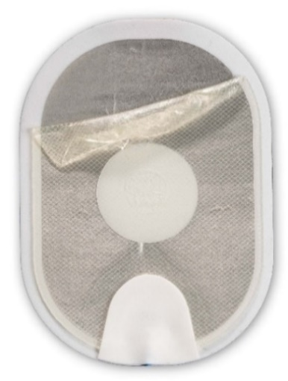  Figure 1: Separated gel that has folded onto itself when peeled.  Action:  Apply pads to the patient.  Do not hesitate. | 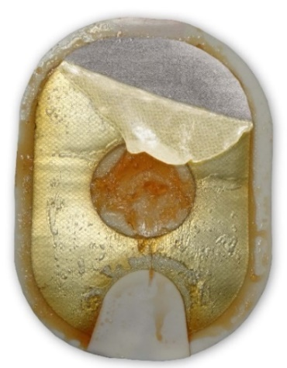  Figure 2: Separated, folded gel may also have a discolored and/or melted appearance.  Action:  Apply pads to the patient.  Do not hesitate. | 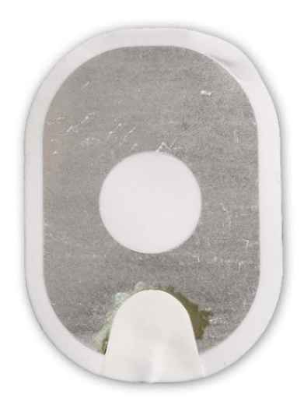  Figure 3: Gel almost completely separated from backing.  Action:  Replace pads cartridge if a spare is available. If no spare is available, perform CPR until help arrives.
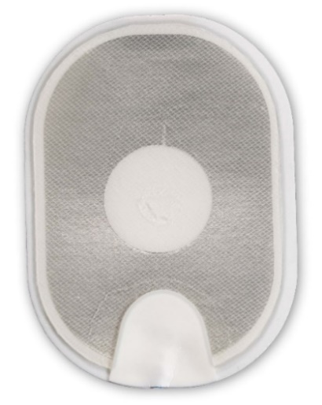
Figure 4: Normal pad.
Action:
Apply pads to the patient according to the Instructions for Use/Owner’s Manual.

- Affected products and how to identify them

Affected products include all Lots of Adult and Infant/Child Pads Cartridges (PNs: M5071A and M5072A) installed in or stored as spares with the HS1, OnSite, and Home AEDs. This notice takes into consideration only pads that are unexpired. Note, subsequent shipments will still be affected until updated pads are available.

The M5071A and M5072A part numbers are located on the pads cartridge and the foil packaging. The M5072A identifier can also be found on the box that Infant/Child pads are shipped in. See photos below with the location of the part number circled.

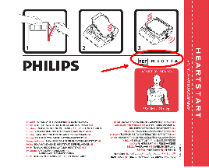 | 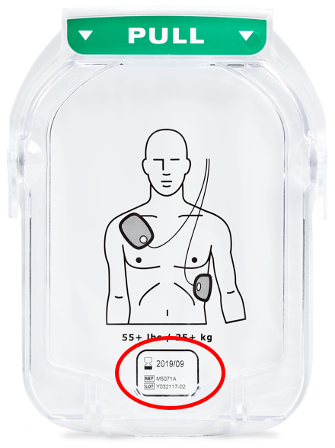 | 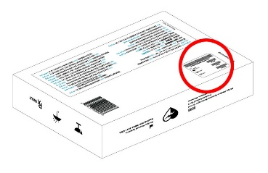 | 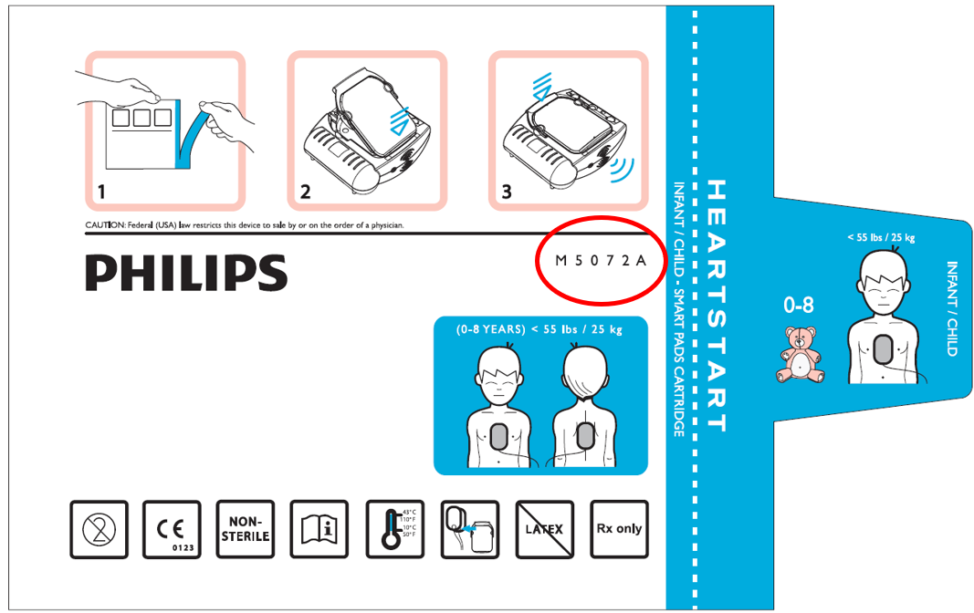 | 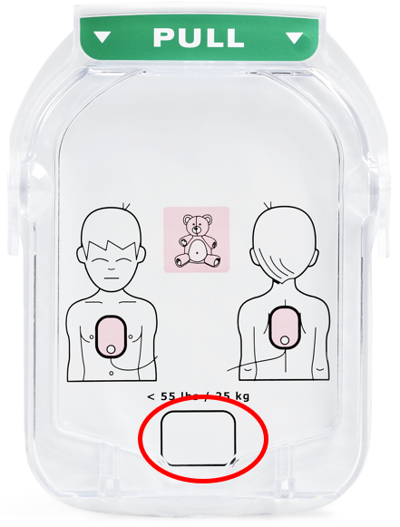
M5071A  foil packaging | M5071A  pads cartridge | M5072A box | M5072A  foil packaging | M5072A  pads cartridge

- Describe the actions that should be taken by the customer / user in order to prevent risks for patients or users

Continue using the HS1/OnSite/Home AED and pads as-is. During use, ensure the majority of the pad surface is covered with gel and apply the pads to the patient. If you notice the gel beginning to separate from the foam backing as you peel, try to prevent the gel from folding onto itself if possible. Do not hesitate to apply the pads to the patient unless the gel has almost completely separated from the backing as in Figure 3. In case of trouble, install spare pads if available and continue the rescue. No matter the state of the pads, follow the voice prompts because the AED will step you through the necessary actions.

Do not try to examine the pads gel prior to patient use. It is not possible to know if your pads are affected by the problem prior to use because the pads are protected by a foil seal. The foil seal on the pads cartridge should be opened only for patient use in an emergency because the pads will quickly dry out if the foil seal is broken.

Philips recommends that you store a spare pads cartridge with your HS1/OnSite/Home AED. A short video showing how to replace the pads cartridge can be found at: www.philips.com/replace-aed-pads-video

If the problem continues and you do not have a spare pads cartridge, attend to the patient, providing CPR if needed, until Emergency Medical Services Personnel arrive.

Please pass this notice to all those who need to be aware within your organization or to any organization where HS1/Onsite/Home AED devices or pads cartridges have been transferred, (if appropriate.)

Keep a copy of this letter with the Instructions for Use/Owner’s Manual of your HS1/OnSite/Home AED because subsequent shipments of M5071A and M5072A pads will still be affected until updated pads are available.

Finally, please complete and return the Reply Form found at the end of this letter.

- Describe the actions planned by the Philips Emergency Care and Resuscitation business to correct the problem

Philips is actively working on design changes intended to eliminate the issue in the M5071A and M5072A pads. Philips projects to release updated pads later in 2022, dependent upon design activities, subcomponent availability, and regulatory approvals. Philips plans to notify eligible customers and supply updated pads.

- Additional information

Users should follow the voice prompts because the AED will step you through the necessary actions. As described in the Instructions for Use, you may hear voice prompts to assist you as shown below.

HS1/OnSite/Home tells you: | Possible cause | Recommended action
…to insert a pads cartridge | The pads cartridge has been damaged. | Insert a new pads cartridge.
…to press pads firmly to the skin  …to make sure the pads have been removed from the liner  …the pads should not be touching the patient’s clothing. | The pads are not properly applied to the patient. | Make sure the pads are sticking completely to the patient’s skin.
…to insert new pads cartridge | The pads cartridge has been opened and the pads peeled off the liner, but the pads have not been successfully  attached to the patient. There may be a problem with the pads  cartridge. | Replace the damaged pads cartridge. Pull up the handle on the cartridge cover, and replace pads on patient with new pads to continue with the rescue.

If you need any further information or support concerning this issue, please contact your local Philips representative. If you need further information or support concerning this issue, please contact your local Philips representative at the UK Philips Customer Care Service Centre on 0870 532 9741 or Ireland Philips Customer Care Service Centre on +353 1 7640229.

This notice has been reported to the appropriate Regulatory Agencies. Be sure to report any occurrence of this issue to Philips, your Philips representative, or to your local Regulatory authority.

Philips regrets any inconvenience caused by this problem.

Sincerely,

Tanya DeSchmidt
Director of Quality
Emergency Care and Resuscitation

URGENT FIELD SAFETY NOTICE RESPONSE FORM
Reference: Gel Separation, M5071A and M5072A, 2021-CC-EC-012

Instructions: Please complete and return this form promptly and no later than 30 days from receipt. Completing this form confirms receipt of the Urgent Field Safety Notice Letter, understanding of the issue, and required actions to be taken.

Customer/Consignee/Facility Name:
Street Address:

City/State/ZIP/Country:

Customer Actions:

- Continue using the pads as-is. During use, ensure the majority of the pad surface is covered with gel and apply the pads to the patient. If you notice the gel beginning to separate from the foam backing as you peel, try to prevent the gel from folding onto itself if possible. Do not hesitate to apply the pads to the patient unless the gel has almost completely separated from the backing. In case of trouble, install spare pads if available and continue the rescue. No matter the state of the pads, follow the voice prompts because the AED will step you through the necessary actions.

- Do not try to examine the pads gel prior to patient use. It is not possible to know if your pads are affected by the problem prior to use because the pads are protected by a foil seal. The foil seal on the pads cartridge should be opened only for patient use in an emergency because the pads will quickly dry out if the foil seal is broken.

- Consider storing a spare pads cartridge with your HS1/OnSite/Home AED. A short video showing how to replace the pads cartridge can be found at: www.philips.com/replace-aed-pads-video

- If the problem continues and you do not have a spare pads cartridge, attend to the patient, providing CPR if needed, until Emergency Medical Services Personnel arrive.

- Please pass this notice to all those who need to be aware within your organization or to any organization where HS1/Onsite/Home AED devices or pads cartridges have been transferred, (if appropriate.)

- Keep a copy of this letter with the Instructions for Use/Owner’s Manual of your HS1/OnSite/Home AED.

I acknowledge receipt and understanding of the accompanying Urgent Field Safety Notice Letter and confirm that the information from this Letter has been properly passed to those who need to be aware.

Name of person completing this form:
Signature:  Printed Name:  Title: | Date  (DD/MM/YYYY):  Telephone Number:  Email Address:
Please return this form by email safetynoticeuki@philips.com

